Task 12: Log Monitoring & Analysis

Objective

Digging through system logs is a must if you want to spot suspicious stuff—things like people trying to break in, brute-force attacks, or just weird activity that doesn’t fit the usual pattern.

Log monitoring is right at the heart of what a SOC analyst does. It’s how you catch incidents, dig into them, and decide what to do next.

Tools You’ll Use

Linux Authentication Logs (/var/log/auth.log)
(If you’re on Windows, use Event Viewer. For bigger setups, SIEM tools like Splunk Free work too.)

Step-by-Step: Monitoring Logs on Linux

Step 1: Check Out the Authentication Logs

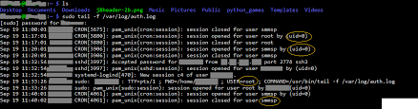

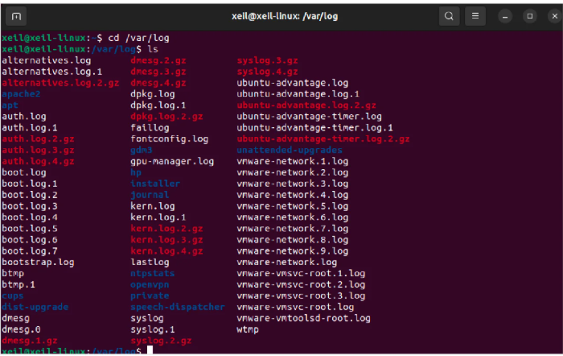

Command:
sudo cat /var/log/auth.log

What’s in there? Every time someone tries to log in—success or fail, SSH or sudo—it gets recorded in this file. Security analysts comb through these logs to spot anyone poking around where they shouldn’t.
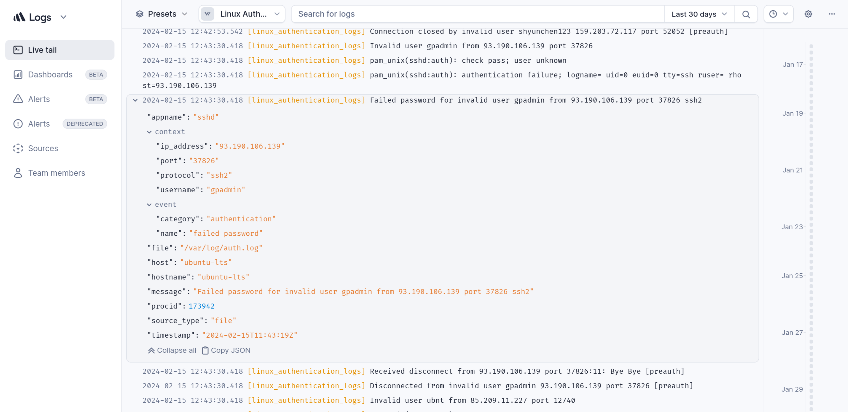

Step 2: Hunt for Failed Logins
Command:
grep "Failed password" /var/log/auth.log

This pulls out every failed login attempt. If you see a bunch of “Failed password” lines, pay attention. It usually means:

- Someone’s using the wrong password
- Someone’s trying random usernames
- SSH attacks are underway

These are the first clues that someone’s hammering away at your system, maybe trying a brute-force or credential stuffing attack.
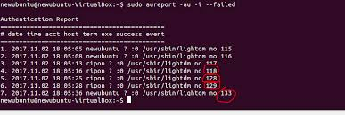

Step 3: Look for Anomalies

An anomaly’s just anything that doesn’t fit the usual login pattern. What should jump out at you?

- Lots of failed logins bunched together
- The same IP address popping up again and again
- Attempts happening really close together

When you spot these, you’re probably looking at a brute-force attack. Security teams flag this stuff fast.

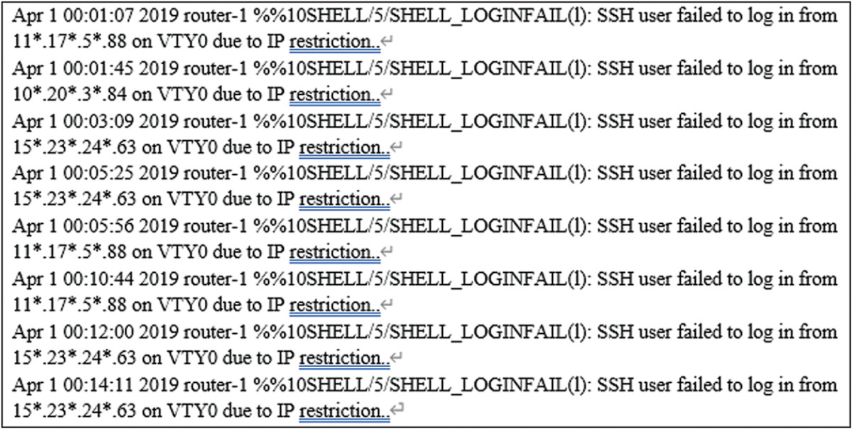

Step 4: Put the Pieces Together

Now, don’t just look at single events. Correlate them—connect the details. Focus on:

- When things happened (timestamp)
- Where they came from (source IP)
- Who they targeted (username)

When analysts connect these dots, they can see how the attacker’s moving, map out the timeline, and know when to block an IP or alert an admin.

Log Analysis Report

Logs Checked:
Linux authentication logs (/var/log/auth.log)

What We Found:
- Lots of failed login attempts
- The same IP address popping up over and over

What Does It Mean?
Looks like someone’s running a brute-force attack on SSH.

Why Logs Matter

Incident Detection
Logs are the first place you see signs of trouble.

Digital Forensics
After something happens, logs help you figure out what went down.

Compliance & Auditing
Need to prove you’re following the rules? Logs have your back.
